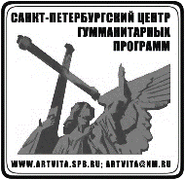
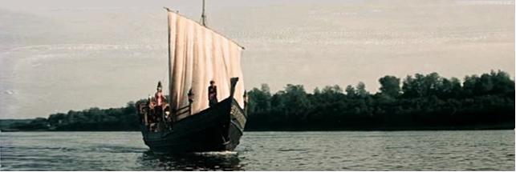
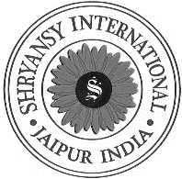
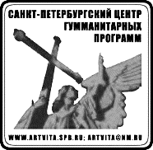

FEDERAL STATE BUDGETARY EDUCATIONAL INSTITUTION OF HIGHER EDUCATION
Saint Petersburg State University of Industrial Technologies and Design
Institute of Design and Fine Arts
Department of Monumental Art

Saint Petersburg Centre for Humanitarian Programs

‘Shryansy International’ Company (Jaipur, Rajasthan, India)

INFORMATIONAL LETTER

Dear Colleagues!

Federal State Budgetary Educational Institution of Higher Education ‘Saint Petersburg State University of Industrial Technologies and Design’ (SPbSUITD), Institute of Design and Fine Arts, and the Department of Monumental Art, ANCO ‘Saint Petersburg Centre for Humanitarian Programs’ (Saint Petersburg, Russia), The Ministry of Culture of the Tver region (Tver, Russia) and ‘Shryansy International’ Company (Jaipur, India) invite Russian and foreign artists, academics, graduate and undergraduate students to participate in the International Intercollegiate Contest ‘A Journey Beyond the Three Seas: 550 Years of Afanasy Nikitin's Journey to India’. The final exhibition will be held in the exhibition halls of SPbSUITD on November 01-15, 2022. The exhibition will be accompanied by the International Scientific and Practical Forum ‘India-Russia. Unity in Diversity. (To the 550th Anniversary of Afanasy Nikitin's Journey Beyond the Three Seas)’, dedicated to the historical and cultural cooperation between Russia and India.
The year 2022 marks the 550th anniversary of the journey of the Tver merchant Afanasy Nikitin to the Indian Bahmani Sultanate, which he described in his travel notes ‘A Journey Beyond the Three Seas’. This event is crucially important in the history of Russian-Indian relations. The development of cultural and creative cooperation between the two countries is a priority task of the event.

Contest Goals
- To exchange the creative and teaching experience and develop international contacts with Russian and foreign colleagues;
-To facilitate creative interaction between artists from different regions of Russia and other countries;
- To support the initiatives of talented fledgling and professional artists in the field of fine arts;
- To create a fruitful environment for creative people to present their achievements in fine arts;
- To promote traditions and reveal innovations in modern fine art in Russia and other countries.

Contest Administration
The organising and exhibition committees are formed to hold the Contest (the Organising Committee and the Exhibition Committee). The Jury is appointed and made up of notable Russian and foreign artists, members of creative unions, representatives of creative organisations and educational institutions.

Contest Participants
The following categories of participants may submit works to the Contest:
- professional artists with higher education in the field of fine art;
- students obtaining higher education in the field of fine art.

Form of Participation
Participation in the exhibition is possible both on-site and off-site (only for participants from other cities and countries). The works of off-site exhibition participants will be shown to the audience during the exhibition on a visual display.

Contest Categories (for all categories of participants):
- Painting: monumental and decorative,
easel,
decorative;
- Graphics: easel,
decorative.

The themes of works may be connected with both the history of Afanasy Nikitin's journey to India or any other events of Russian-Indian relations, reflecting the culture, everyday life and nature of Russia and India. It is possible to submit works in the genres of thematic painting based on historical material, architectural landscape.

Contest Procedures:
The Contest has several stages:
Stage 1 – sending applications by October 1, 2022 г. to russia-india-konkurs@mail.ru in Microsoft Word format (Appendices 1, 2), put ‘A Journey Beyond the Three Seas: 550 Years of Afanasy Nikitin's Journey to India’ in the subject line of an e-mail.
Application Form should be sent with:
- photo of the work (without other objects and a frame) in JPEG / JPG format, with a resolution of 300 dpi, with a maximum size of 3000x3000 pixels. Name of the file – Name and Surname of the author, the Title of the Work. The works made in graphic editors will not be considered by the Exhibition Committee,
- photo of the author,
- short creative biography,
- label for on-site participants (Appendix 3).
Stage 2 – the Organising Committee and the Exhibition Committee select the works for participation in the Contest and inform the authors about their decision by October 15, 2022.
Stage 3 – October 31, 2022 by 12:00 on-site participants deliver their works to SPbSUITD (Saint Petersburg, metro station Admiralteyskaya, Bolshaya Morskaya Ulitsa, 1st floor, recreation hall), framed by the authors, with the name of the author and the title of the work on the back. Graphic works must be framed using a plastic glass, otherwise, the Organising Committee assumes no responsibility for the glass.
Stage 4 – installation of the exhibition by the members of the Exhibition Committee.
Stage 5 – November 01 – opening of the exhibition of works submitted to the Contest.
Stage 6 – announcement of the results of the Contest, work of the Jury.
Stage 7 – November 14 – de-installation of the exhibition.

The Organising Committee assumes no responsibility for the works left at the University for more than 14 days after the end of the exhibition. Authors from other cities and countries wishing to participate in the exhibition pay travel, accommodation and meals expenses on their own.

Contest Results
Contest participants will receive certificates, prizes, awards, and journeys. Laureates (winners) and prize-winners (1, 2, 3 places) will be awarded the Diplomas (presented in person) and creative journeys for plein air from the founders of the Contest: to India (from ‘Shryansy International’ company) and across Russia under the project ‘Russian Atlantis’ from the Saint Petersburg Centre for Humanitarian Programs. The outcome of the Contest will be the final exhibition of works held at the exhibition halls of SPbSUITD, as well as in Tver, Moscow and India.
All Contest participants will be awarded the Certificates of Participation (off-site participants will receive digital certificates).
The founders and organisers of the Contest have the right to add other contest categories. Based on the Contest results, a digital catalogue will be published and sent to all on-site and off-site participants.

Contact Details of the Exhibition and Contest Organising Committee:
Saint Petersburg Centre for Humanitarian Programs:
Phone: +7 (911) 999-30-95;
+7 (911) 999-30-96;
SPbSUITD Institute of Design and Fine Arts:
Phone: +7 (812) 310-24-27; +7 (812) 310-43-17 (Department of Monumental Art);
+7 (812) 315-13-49 (Institute of Design and Fine Arts);
+7 (911) 286-90-80 (mobile).
E-mail: russia-india-konkurs@mail.ru

Appendix 1

APPLICATION FORM
(for professional artists)
for participation in the International Intercollegiate Contest
‘A Journey Beyond the Three Seas: 550 Years of Afanasy Nikitin's Journey to India’

Full name
Country
Organisation (full and abbreviated names)
Position
Title, degree
Membership in creative unions
Phone
E-mail
Address with a postal code
Form of participation (on-site / off-site)
Category of participant | Professional artist
Contest category
Title of the work
Size (height х width)
Technique, media
Year

Appendix 2

APPLICATION FORM
(for students)
for participation in the International Intercollegiate Contest
‘A Journey Beyond the Three Seas: 550 Years of Afanasy Nikitin's Journey to India’

Full name
Country
University (full and abbreviated name)
Phone
E-mail
Address with a postcode
Form of participation (on-site / off-site)
Category of participant | Student
Contest category
Title of the work
Size (height х width)
Technique, media
Year
Full name of the academic advisor
Organisation, position of the academic advisor

Appendix 3
LABEL
(for on-site participation)
Full name
professional artist / student
«Title of the work»
Technique, media, year
Country, year

